**Kingdom of Saudi Arabia**

**Ministry of Education**

**King Faisal University**

**College of Computer Sciences & Information Technology**





**Course Project**

**Course Name:** Network Forensics.

**Project Title:** Network Forensics investigation at SADAIA.

**Instructure:** Dr. Abdullah.

**Section:** 61

June 2023

|  |  |
| --- | --- |
| Project Team: | |
| Name | **ID** |
| Huda Al-doghan. | 219032654 |
| Nouf Al-zuabi. | 219017761 |
| Sara Al-salem. | 219037960 |

TABLE OF CONTENTS

LIST OF FIGURES 3

1. Introduction 5

2. Evidence 5

2.1 Man-in-Middle Attack 5

2.2 Ettercap Launching 7

2.3 Adding Targets 9

2.4 Starting the Spoofing Attack 10

2.5 Wireshark attack monitoring 12

2.6 Arp Spoofing Attack 13

2.7 ARP Spoofing with Wireshark or Ettercap 13

2.8 Wireshark Analysis 17

2.9 Dos Attack 19

2.10 Attack demonstration 20

2.11 Evidence of Traffic 25

3. Objectives 25

4. Forensic Analysis 26

4.1 Man-In-Middle Attack Forensic Analysis 26

4.2 ARP Cache poisoning Attack Forensic Analysis 27

4.3 DoS Attack Forensic Analysis 28

5. Relevant Findings 29

5.1 Findings Man-In-Middle Attack 29

5.2 Findings of ARP Cache Poisoning Attack 29

5.3 Findings of DoS Attack 30

6. Challenges and troubleshooting 30

7. Conclusions 30

References 31

# LIST OF FIGURES

Figure 1(Kali IP Address) 5

Figure 2(Windows IP Address) 6

Figure 3(attacker to target ping) 6

Figure 4(pinging from target to attacker) 6

Figure 5(launched Ettercap) 7

Figure 6(Ettercap dashboard) 7

Figure 7(Ettercap host menu) 8

Figure 8(scaning) 8

Figure 9(scan for host lists) 8

Figure 10(discovered hosts) 9

Figure 11(added target1) 9

Figure 12(target host) 9

Figure 13(Selected the target host) 10

Figure 14(target host added in Ettercap) 10

Figure 15(forwarded the traffic) 10

Figure 16(ARP poisoning menu) 11

Figure 17(Initiating attack) 11

Figure 18(attack launched) 11

Figure 19(browsing on target machine) 12

Figure 20(suspicious Wireshark traffic) 12

Figure 21(Wireshark traffic) 13

Figure 22(IP address of attacker) 14

Figure 23 (IP address of target machine) 14

Figure 24(pinging target machine) 15

Figure 25(Viewing ARP table) 15

Figure 26(Enabled IP forwarding) 16

Figure 27 (ARP Spoofing Attack Launch) 16

Figure 28(Browsing website) 17

Figure 29(monitoring http traffic) 17

Figure 30(Wireshark traffic) 18

Figure 31(HTTP stream) 18

Figure 32(IP address of Kali) 19

Figure 33(IP address of Windows) 20

Figure 34(launched Ettercap) 20

Figure 35 (Dashboard of Ettercap) 21

Figure 36 (Host List) 21

Figure 37(Host list) 22

Figure 38(Added windows host to target 1) 22

Figure 39(target 1) 22

Figure 40 Manage plugins 23

Figure 41(DoS_attack plugin) 23

Figure 42(mentioned target IP) 23

Figure 43(DoS attack Lauched) 24

Figure 44(browsing on target vm) 24

Figure 45 (Attack Traffic) 24

Figure 46(Wireshark ARP cache Traffic) 25

Figure 47(Man-in-Middle Attack) 27

Figure 48(ARP cache poisoning Attack) 27

Figure 49 (Http stream) 28

Figure 50 (Wireshark traffic) 28

Figure 51 (Packet Detail) 29

# **Introduction**

Network forensics is a specialized field within digital forensics that focuses on the comprehensive examination of network activities and data transmission across networks believed to be engaged in malicious behavior. Its primary objective is to investigate networks involved in activities such as the propagation of malware, credential theft, and the analysis of cyber-attacks. As the internet has expanded, cybercrimes have also increased, underscoring the importance of network forensics. This has been driven by the growth and widespread adoption of network-based services like the World Wide Web and email. To effectively identify and analyze attacks, investigators must possess a deep understanding of network protocols and applications, including web protocols, email protocols, network protocols, and file transfer protocols, among others.

During network forensics investigations, experts examine data derived from network traffic gathered from networks suspected of involvement in cybercrime or specific cyberattacks. By scrutinizing this network traffic data, investigators search for evidence of file manipulation, human communication, and other relevant information that may provide insights into the nature and origin of the incident.

# **Evidence**

## 2.1 Man-in-Middle Attack

**Information of Networking**

First, we check the IP address of kali Linux machine using command

**ifconfig**

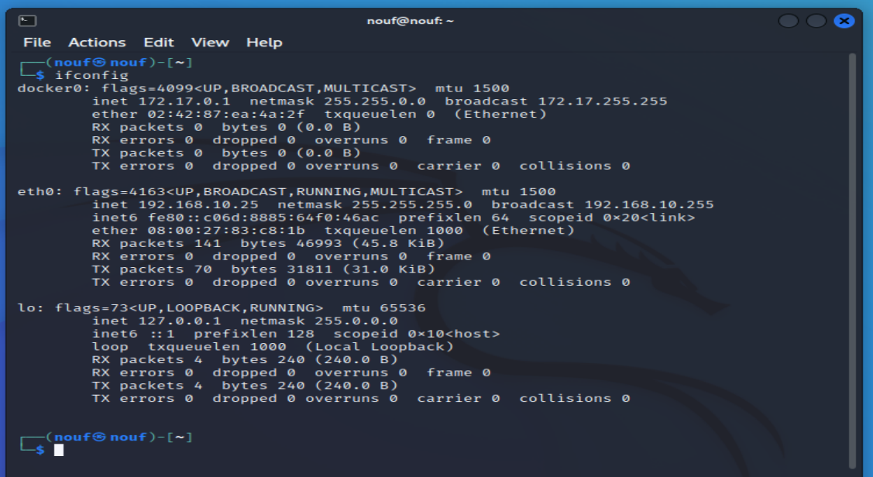

Figure 1(Kali IP Address)

After that we check the IP address of target machine using command:

**ipconfig**

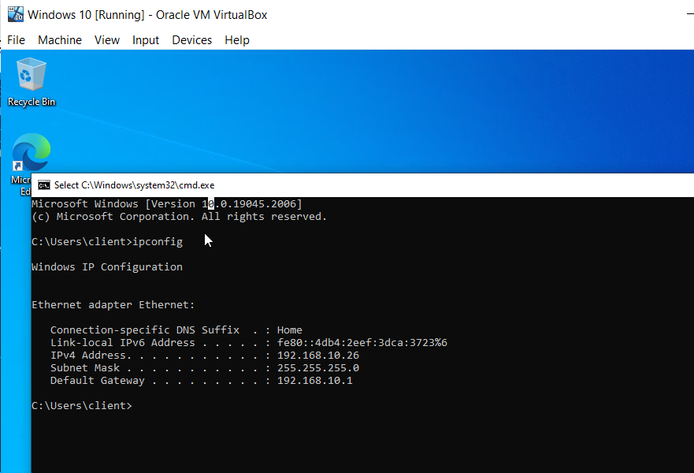

Figure 2(Windows IP Address)

Here we verified the connectivity between kali Linux and target machine

**ping 192.168.10.26**

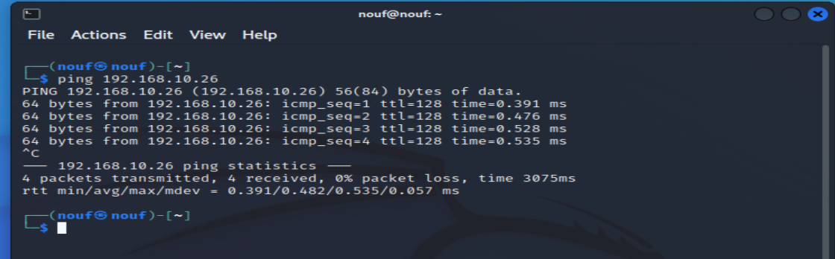

Figure 3(attacker to target ping)

Ping from windows to kali Linux machine.

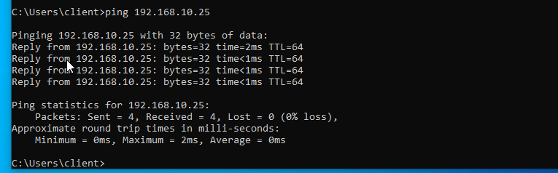

Figure 4(pinging from target to attacker)

## 2.2 Ettercap Launching

Now we open the Ettercap using command.

**sudo etthercap –G**

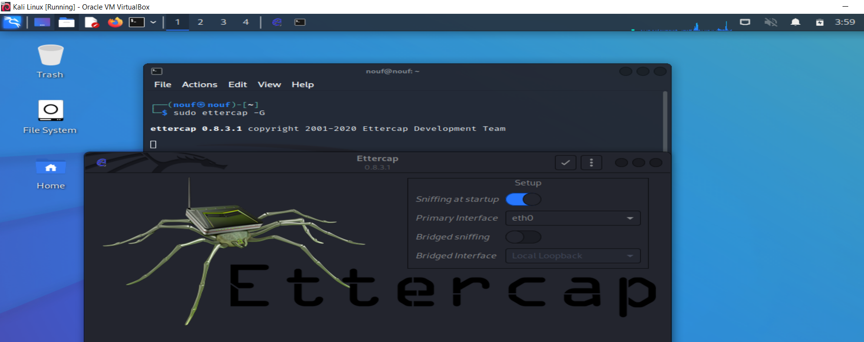

Figure 5(launched Ettercap)

As you can see above the design is completely different with the main difference being the menu options. Those options are now integrated within the application window. Unified sniffing is selected as the default, so at this point simply ensure that the correct interface you want to begin sniffing on is selected. Most of the time this will be eth0. Next, click on the check mark to the right to

**Hosts Adding to Ettercap**

Begin by looking at the top left of the application window and click on the magnifying glass icon. This will scan for hosts within your network. In our case, we are looking for the IP you copied from the previous step, which will be our Windows 10 machine. We also need to look for the default gateway address in the host list as well. Below you will find 3 screenshots that show each step with the last enabling you to view the current host list:

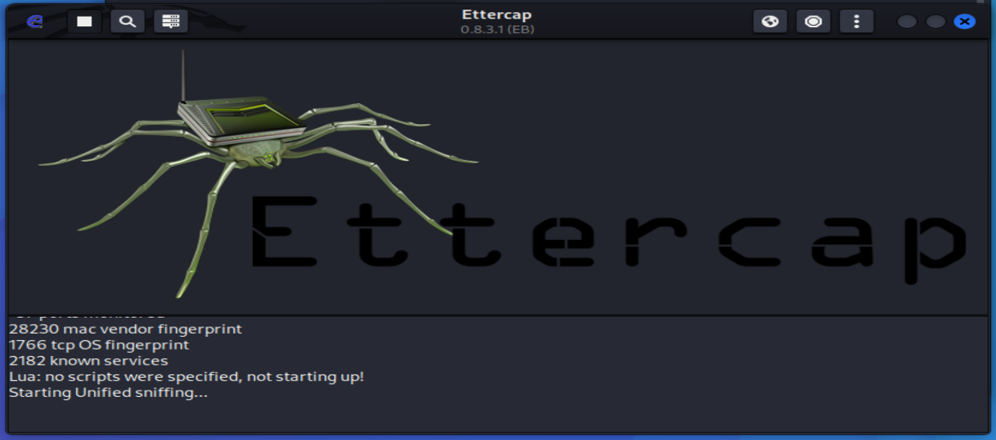

Figure 6(Ettercap dashboard)

Here we click on the hosts from the menu.

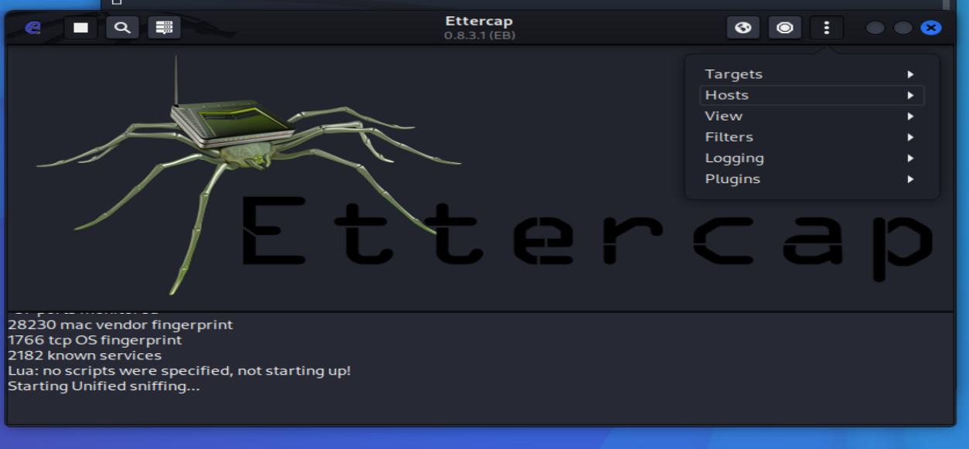

Figure 7(Ettercap host menu)

here we scan for the hosts.

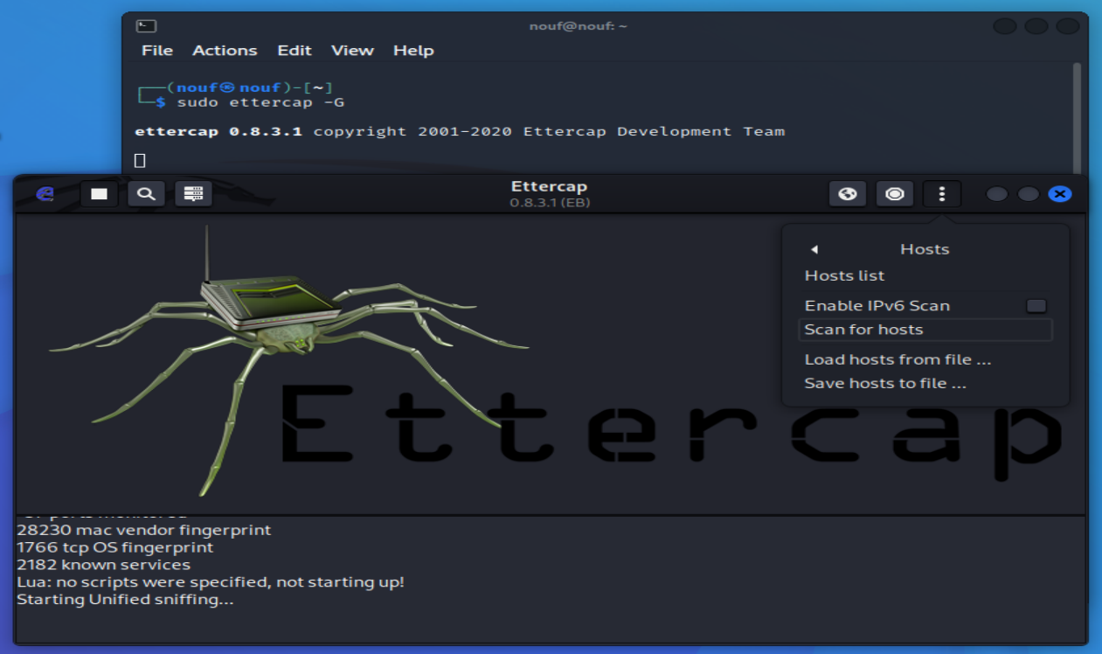

Figure 8(scaning)

Then after that we click on the hosts list.

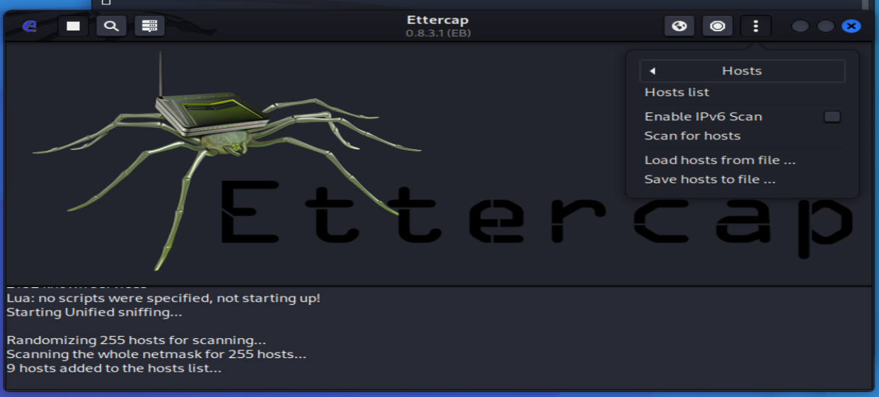

Figure 9(scan for host lists)

Here we found the host lists and my target host is 192.168.10.26 as you can see in the attached screenshot below.

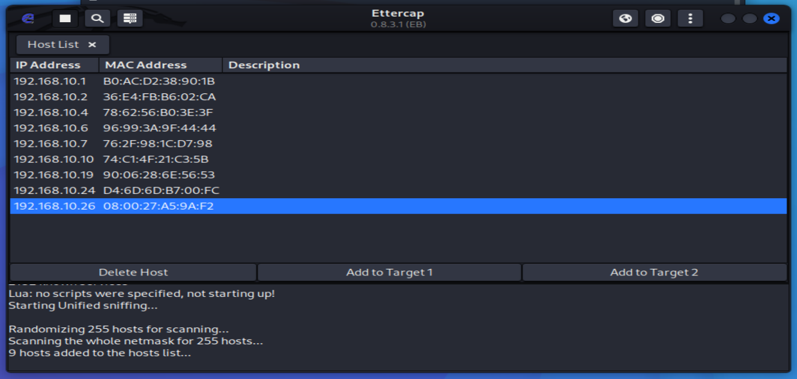

Figure 10(discovered hosts)

## 2.3 Adding Targets

So, from the hosts list we added 192.168.10.26 and click Add to Target 1.

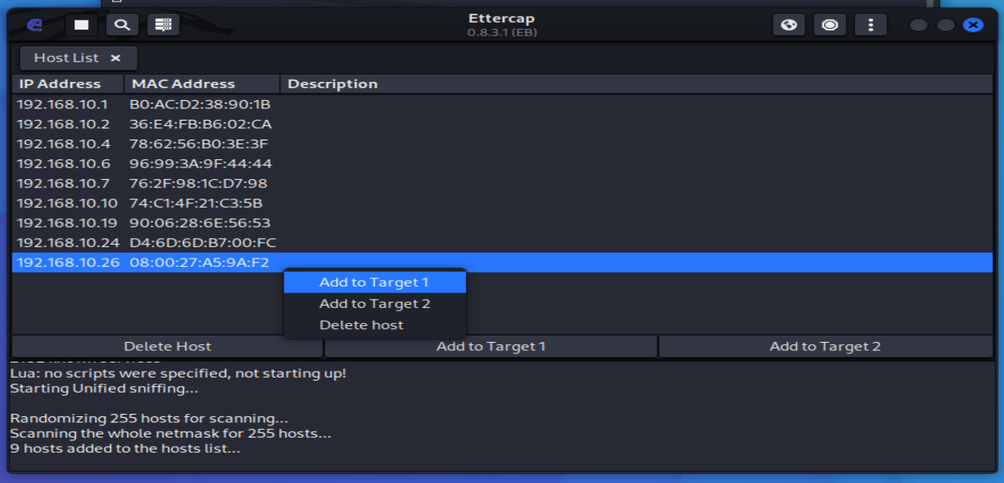

Figure 11(added target1)

Host 192.168.10.26 has been added to Target 1.

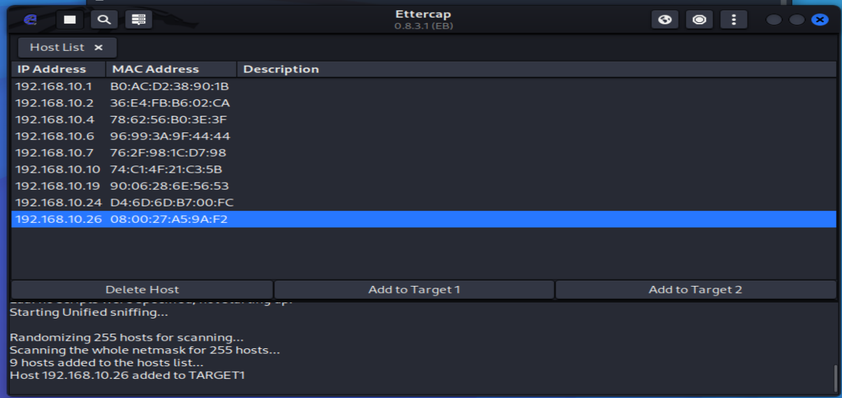

Figure 12(target host)

After that we click on the current target.

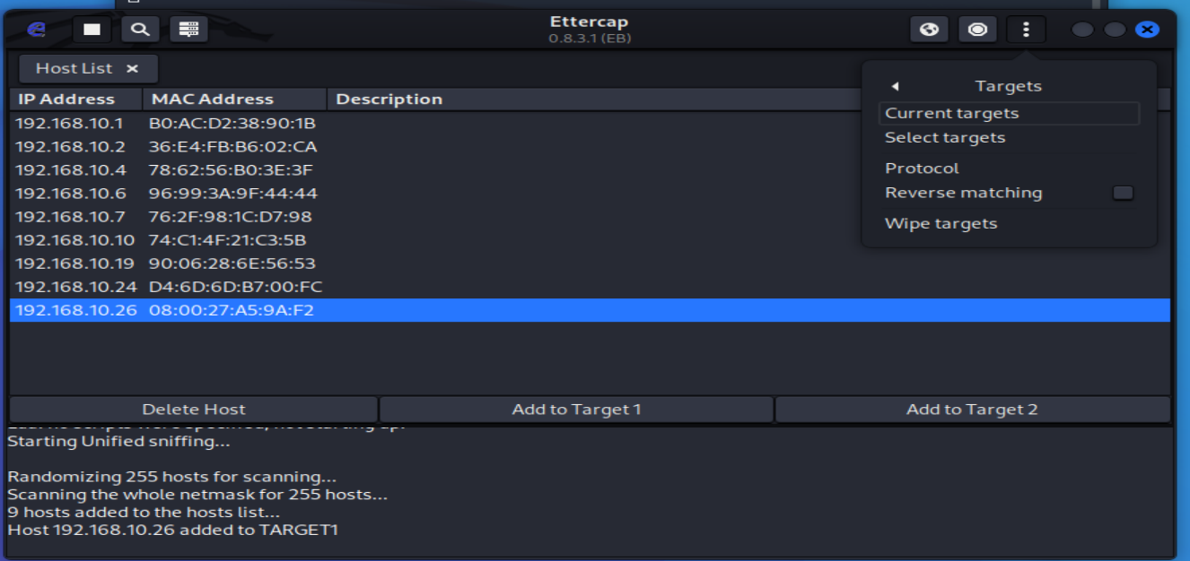

Figure 13(Selected the target host)

Here you can see my target host in the screenshot below.

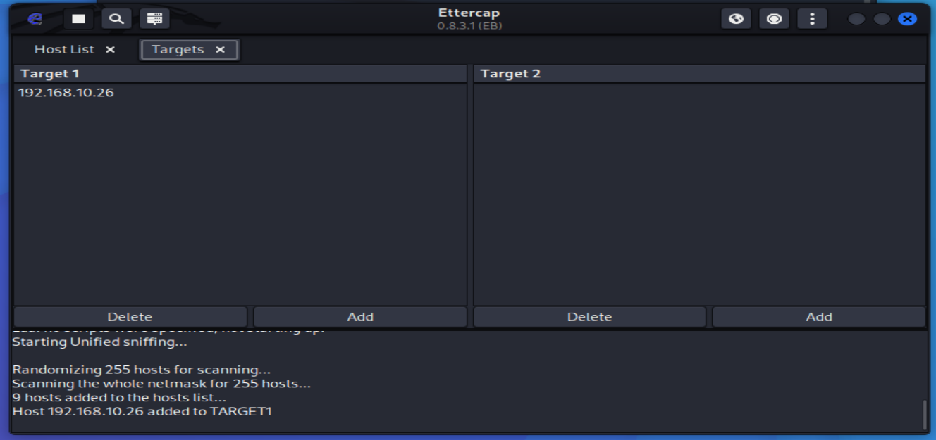

Figure 14(target host added in Ettercap)

## 2.4 Starting the Spoofing Attack

For our attack machine to forward the traffic correctly to and from both targets, we need to enable IP forwarding. This is done by entering the following command via the terminal.

**─$ sudo sysctl -w net.ipv4.ip_forward=1**

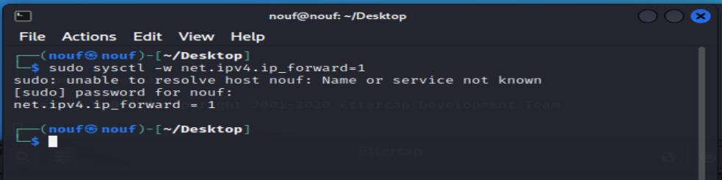

Figure 15(forwarded the traffic)

We want to select the first one, ARP Poisoning. Once that is selected, it will bring up a small window in which we select OK, keeping the current default choices. (See screenshots below).

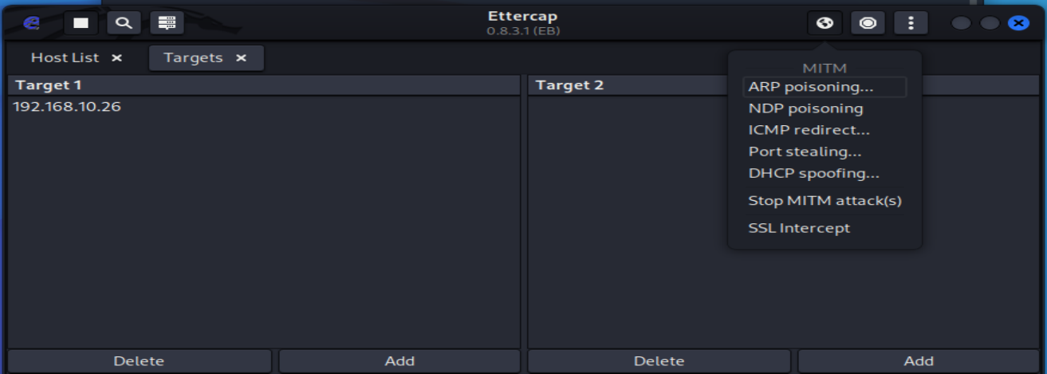

Figure 16(ARP poisoning menu)

Here we confirm the ARP spoofing attack and click on ok

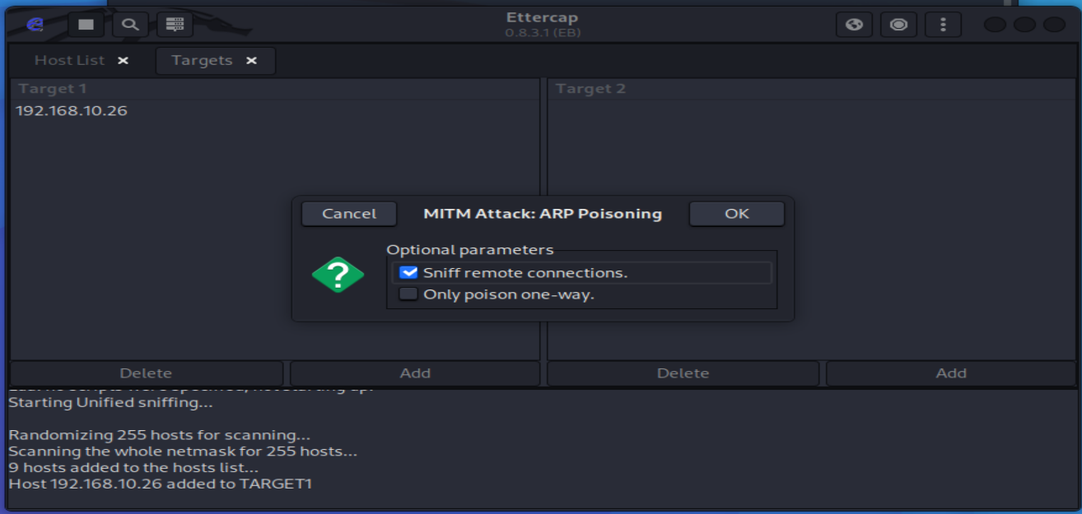

Figure 17(Initiating attack)

Attack has started now.

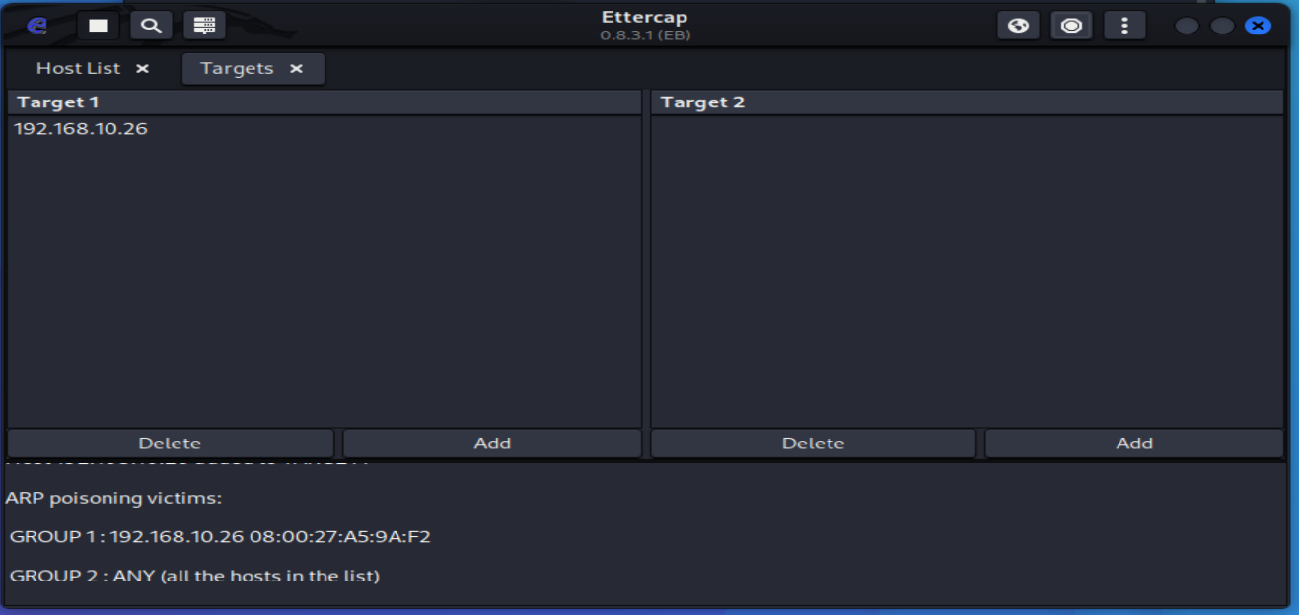

Figure 18(attack launched)

On the other side we open the target machine and trying to access google I got the following response.

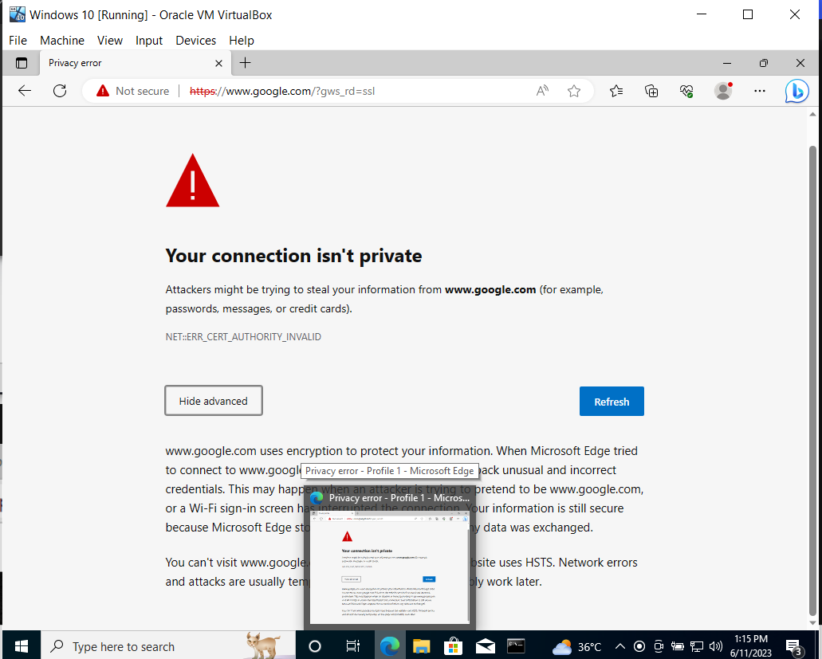

Figure 19(browsing on target machine)

## 2.5 Wireshark attack monitoring

Here you can see the Wireshark traffic ARP traffic shown the attack.

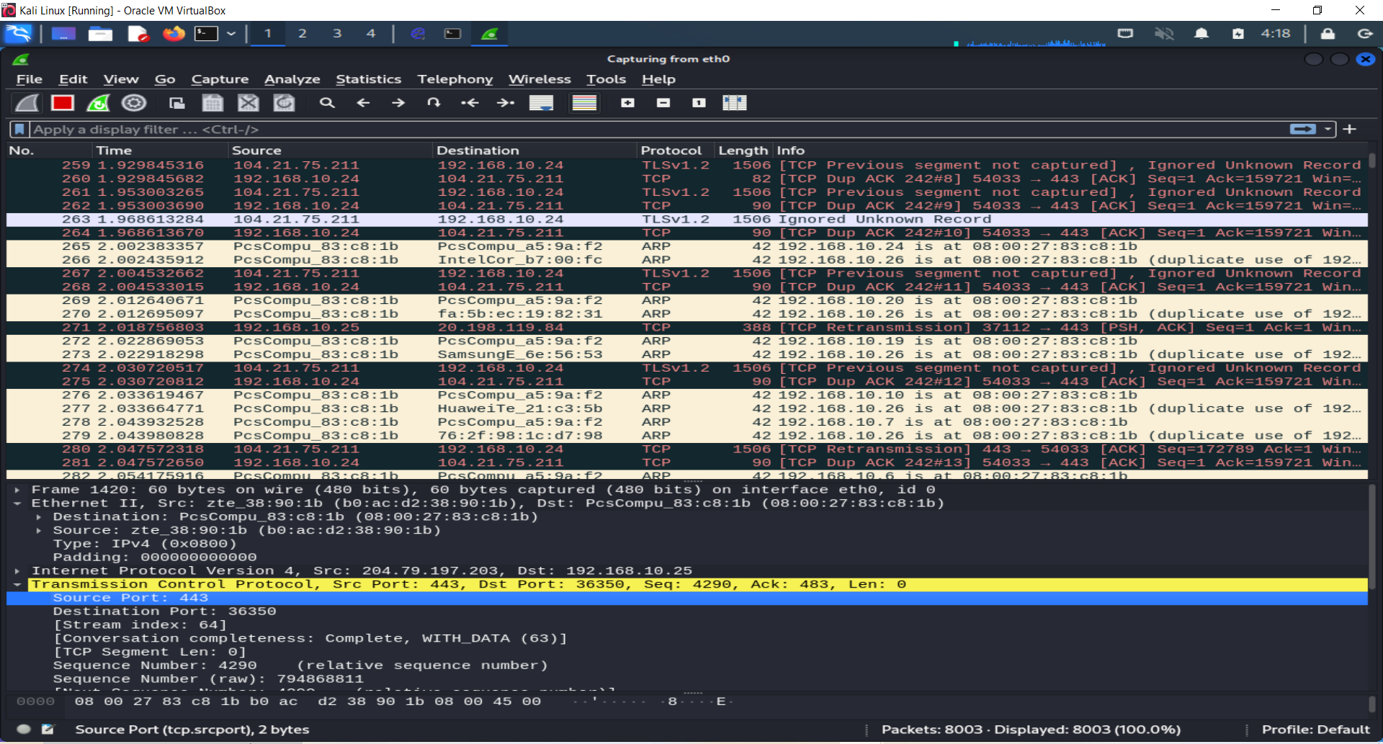

Figure 20(suspicious Wireshark traffic)

See below duplication IP address detected for 192.168.10.26.

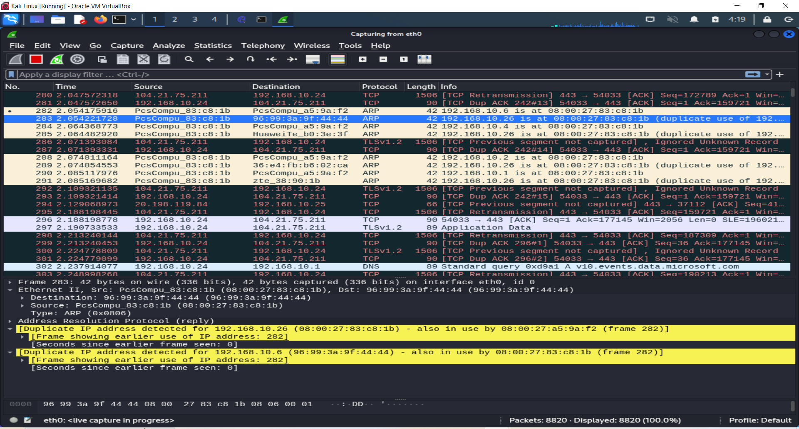

Figure 21(Wireshark traffic)

## 2.6 Arp Spoofing Attack

The Address Resolution Protocol (ARP) is a stateless protocol utilized in local area networks (LANs) to convert IP addresses to physical MAC (media access control) addresses. However, malicious individuals can exploit this protocol by associating their MAC address with the IP address of a legitimate user. They achieve this by generating numerous ARP request packets, leading to the poisoning of the target machine's ARP cache with false entries. Consequently, any data sent by the user to the host IP address will unknowingly be redirected to the malicious user instead.

## 2.7 ARP Spoofing with Wireshark or Ettercap

To perform ARP spoofing and capture clear text passwords from vulnerable websites, we require a client machine on the LAN. In this demonstration, the client (windows 10) machine's IP address is 192.168.10.28, while the Kali Linux attacker's IP address is 192.168.10.25.

First, we check the IP address Kali Linux machine using “ifconfig” command as you can see below in screenshot.

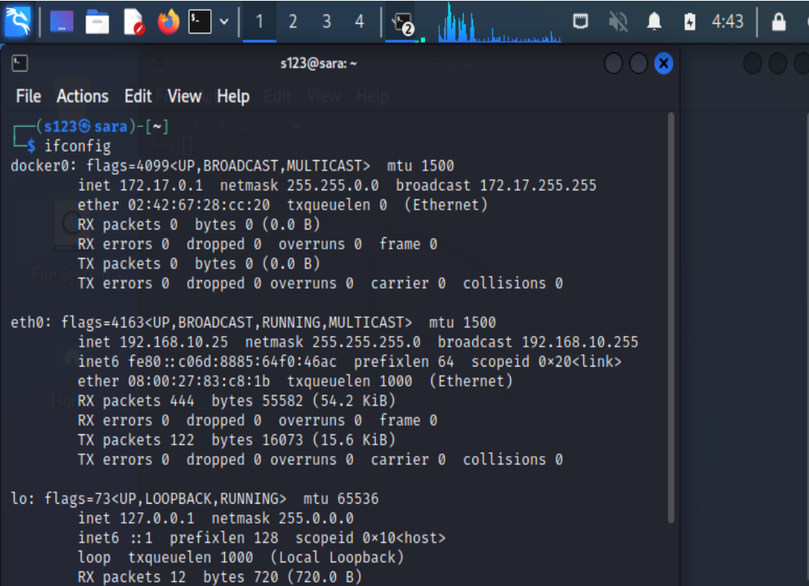

Figure 22(IP address of attacker)

After that we check the IP address of client (Windows) machine.

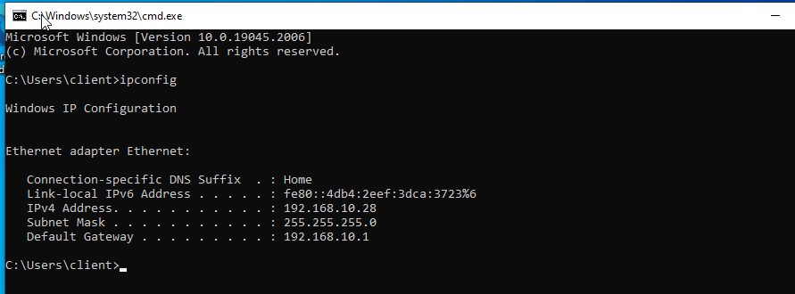

Figure 23 (IP address of target machine)

Here we follow these steps in the terminal:

Ping the target machine to verify and add its IP address to your ARP table.

**ping 192.168.10.28 –c 3**

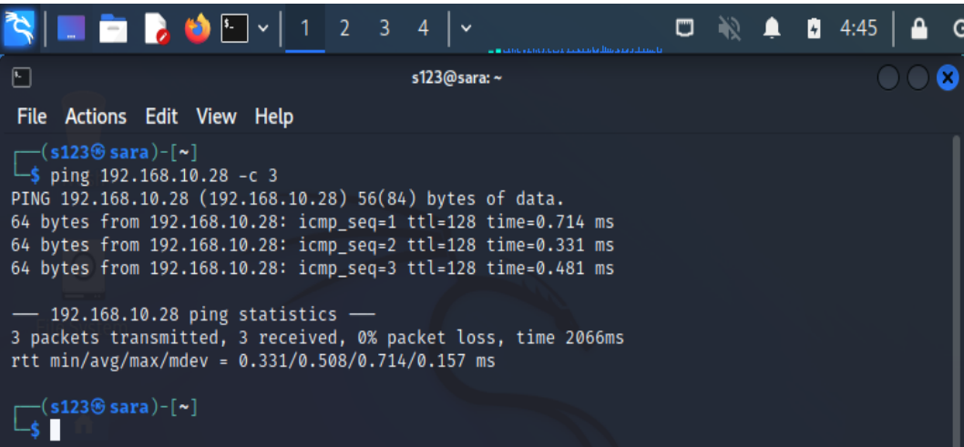

Figure 24(pinging target machine)

Enter "arp" in the terminal command line to view the ARP table.

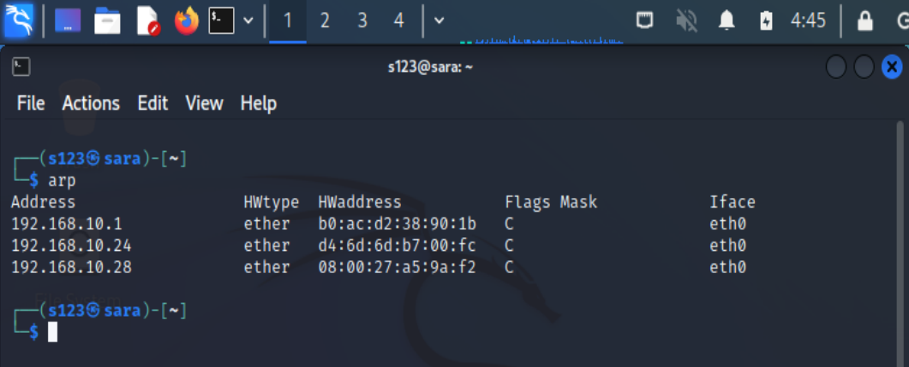

Figure 25(Viewing ARP table)

By default, IP forwarding is disabled in modern Linux systems for security purposes. Temporarily enable it by typing: "echo 1 > /proc/sys/net/ipv4/ip_forward".

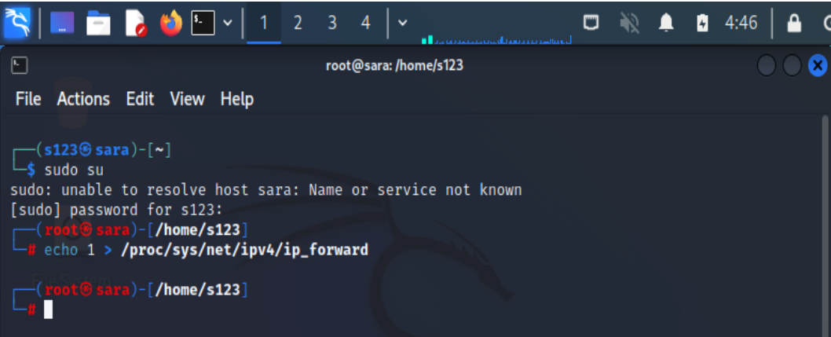

Figure 26(Enabled IP forwarding)

To perform ARP poisoning, use the following command syntax: "arpspoof -i interface -t target remote host".

**sudo arpspoof –I eth0 –t 192.168.10.28 192.168.10.25**

here in output, you can see we are sending message in that message we are spoofing on the target system on this network.

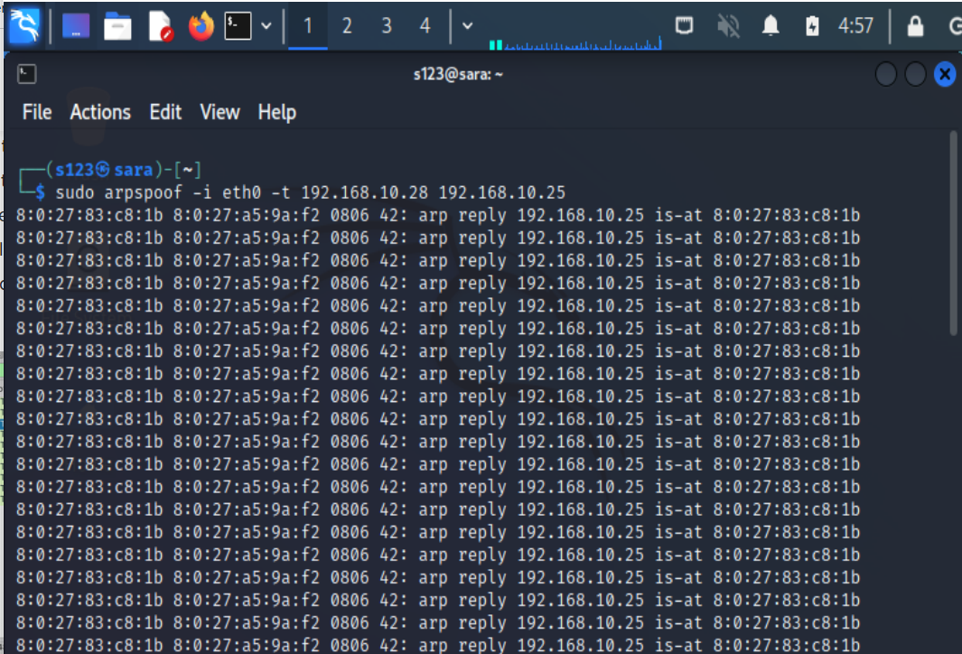

Figure 27 (ARP Spoofing Attack Launch)

On the target machine we searched for the google.

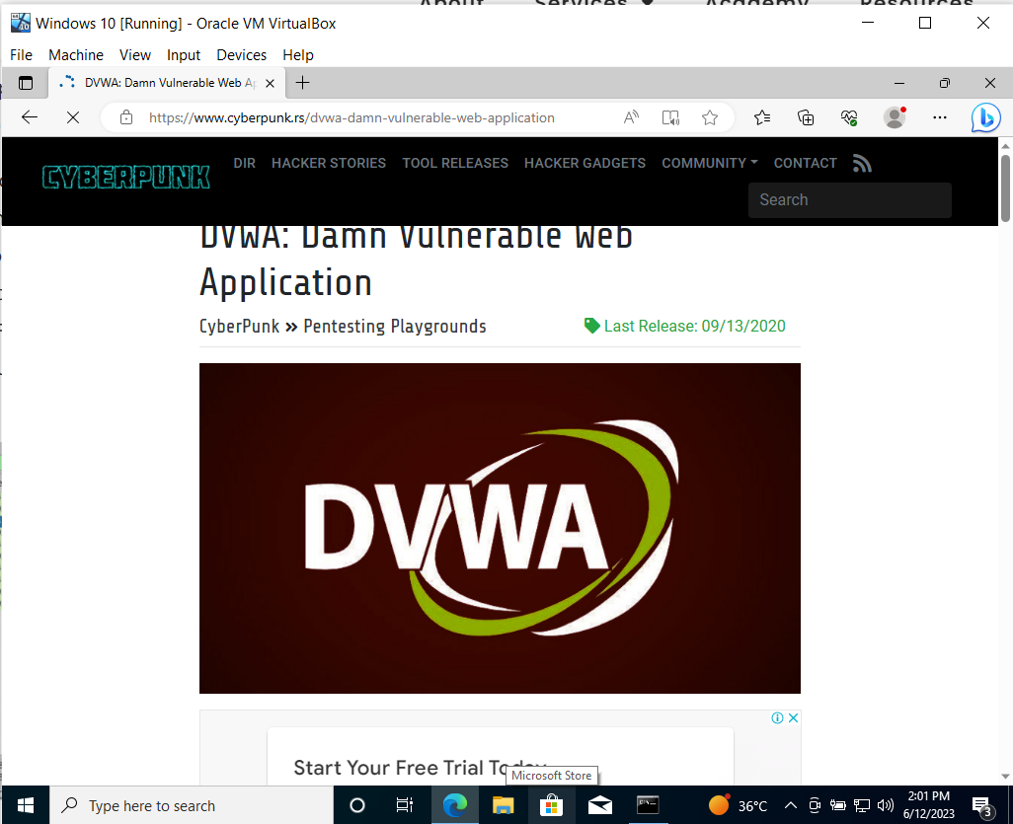

Figure 28(Browsing website)

## 2.8 Wireshark Analysis

In Wireshark we applied the filter of http traffic and checked the http traffic of target machine on attacker machine Wireshark.

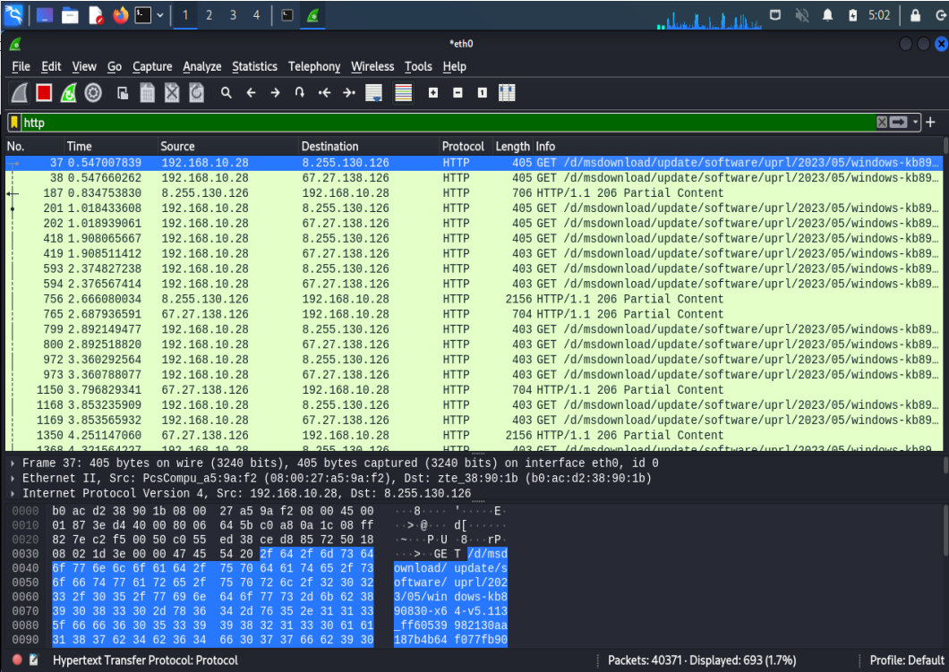

Figure 29(monitoring http traffic)

Here you can see all the http traffic of target machine is shown and its spoofed and we are monitoring through Wireshark on my attacker machine.

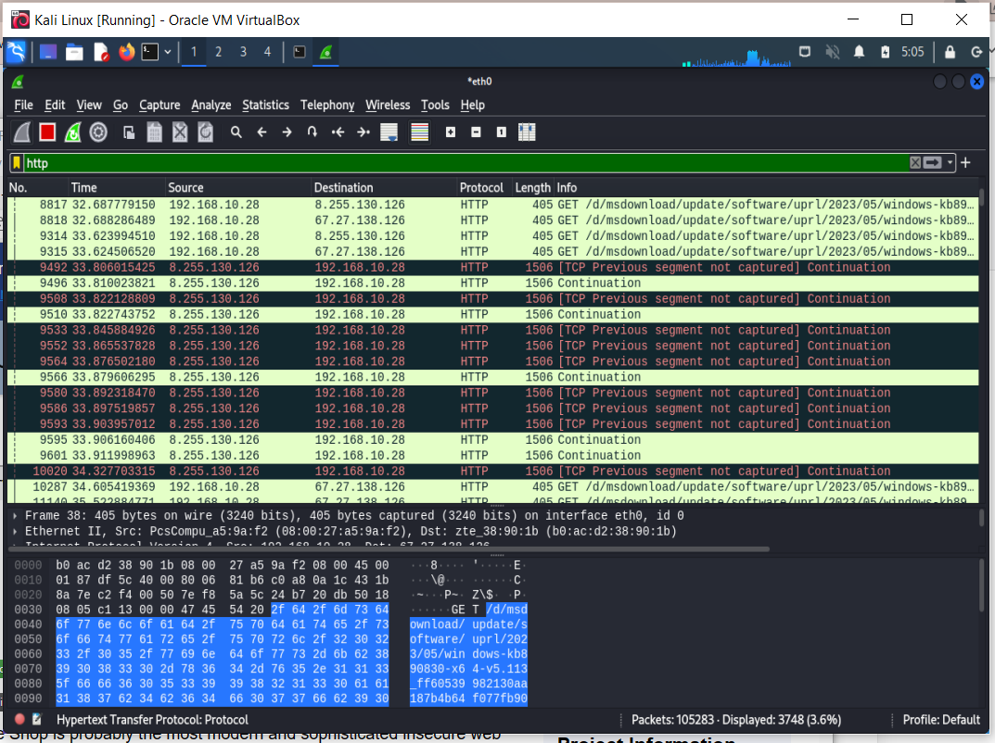

Figure 30(Wireshark traffic)

Here we can clearly see the network traffic http stream details you can see below in screenshot.

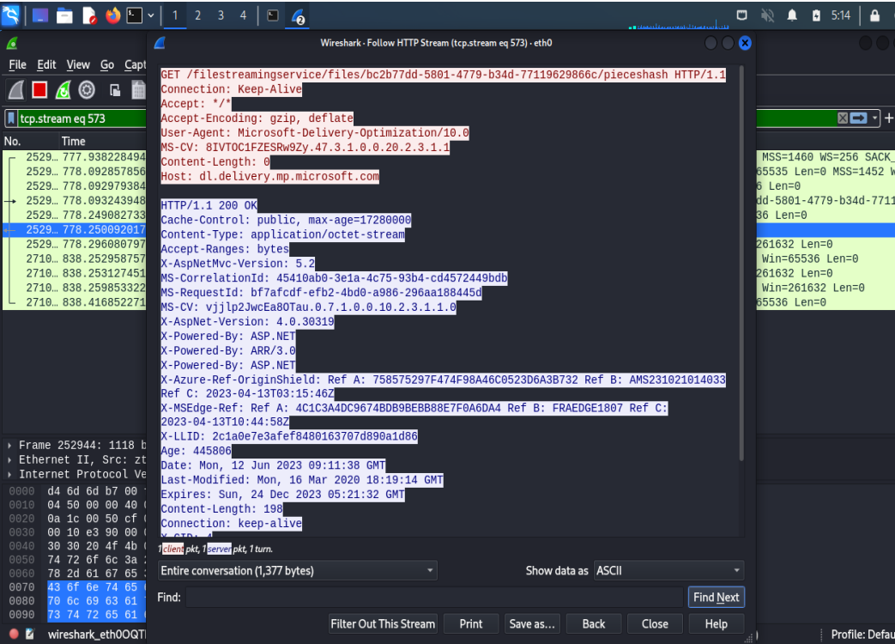

Figure 31(HTTP stream)

## 2.9 Dos Attack

A Denial of Service (DoS) attack is classified as a type of cyber assault where an attacker endeavors to cripple a network or server by overwhelming it with a massive amount of traffic, rendering it inaccessible to authorized users. This malicious act can be achieved through various methods, such as amplification, flooding, or reflection. To mitigate the risks posed by such attacks, it is crucial to implement appropriate security measures, including rate limiting and traffic filtering.

Before performing the attack, we check the IP address of the kali Linux (Attacker) machine using the command:

**ifconfig**

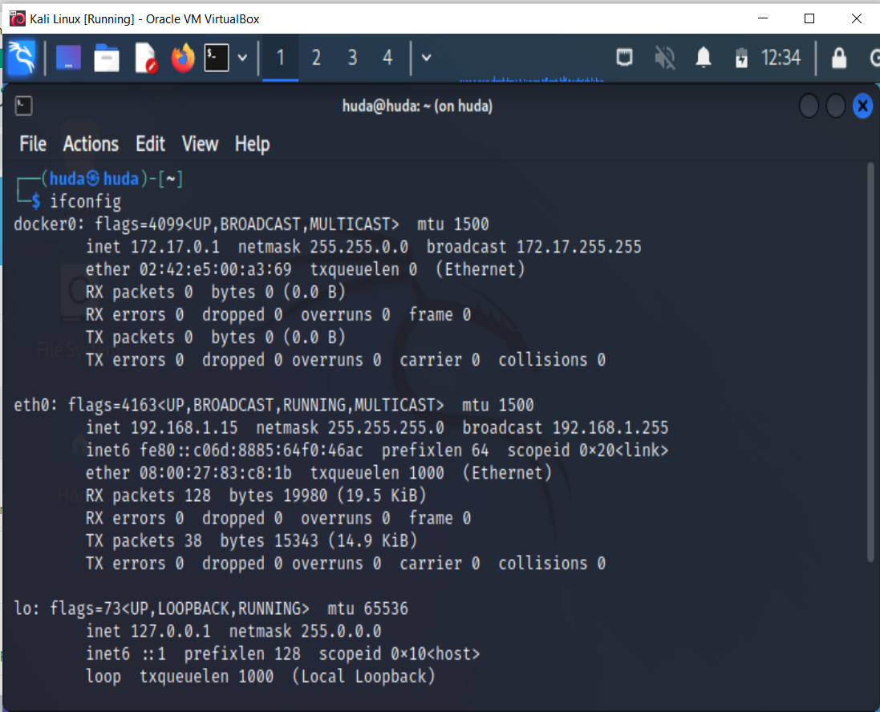

Figure 32(IP address of Kali)

After that we check the windows 10 (Target machine IP) which is 192.168.1.14 as you can see in below attached screenshot.

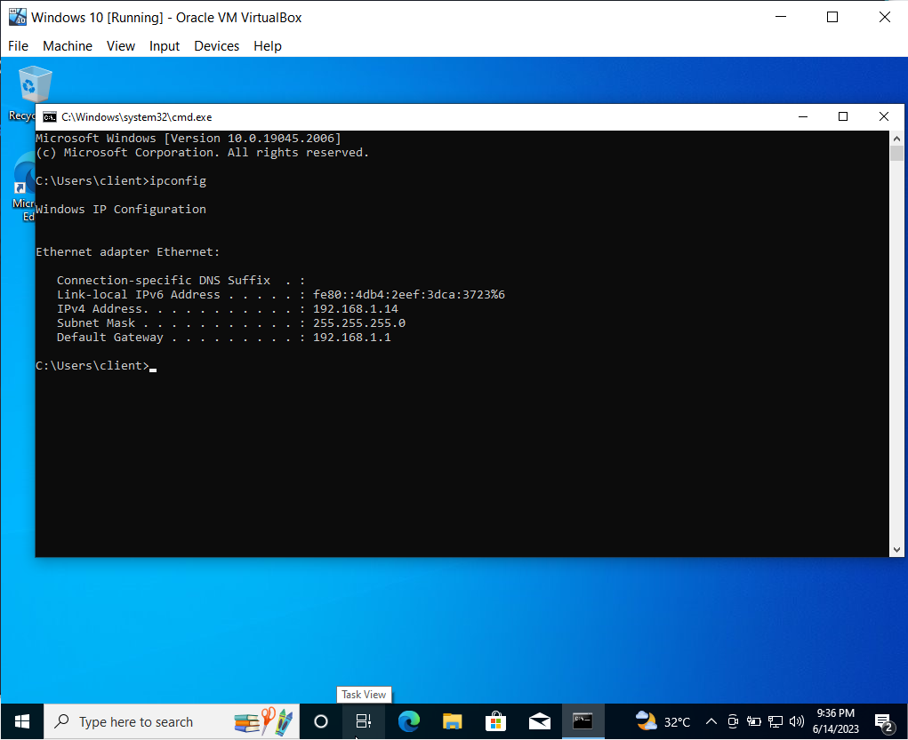

Figure 33(IP address of Windows)

## 2.10 Attack demonstration

As depicted in the screenshot, we initiated the Ettercap-graphical tool in Kali Linux.

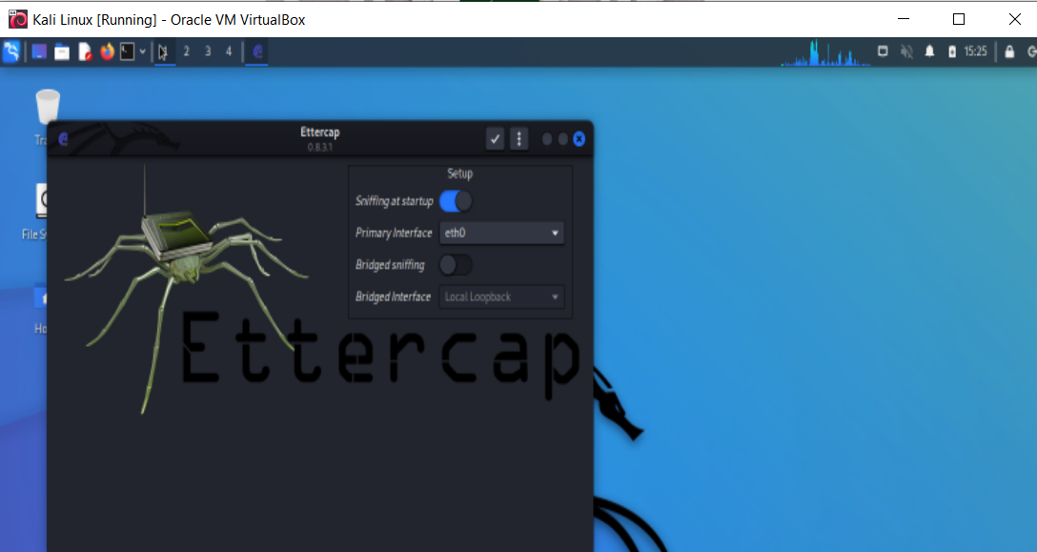

Figure 34(launched Ettercap)

Then the following window has been appearing to me as you can see below.

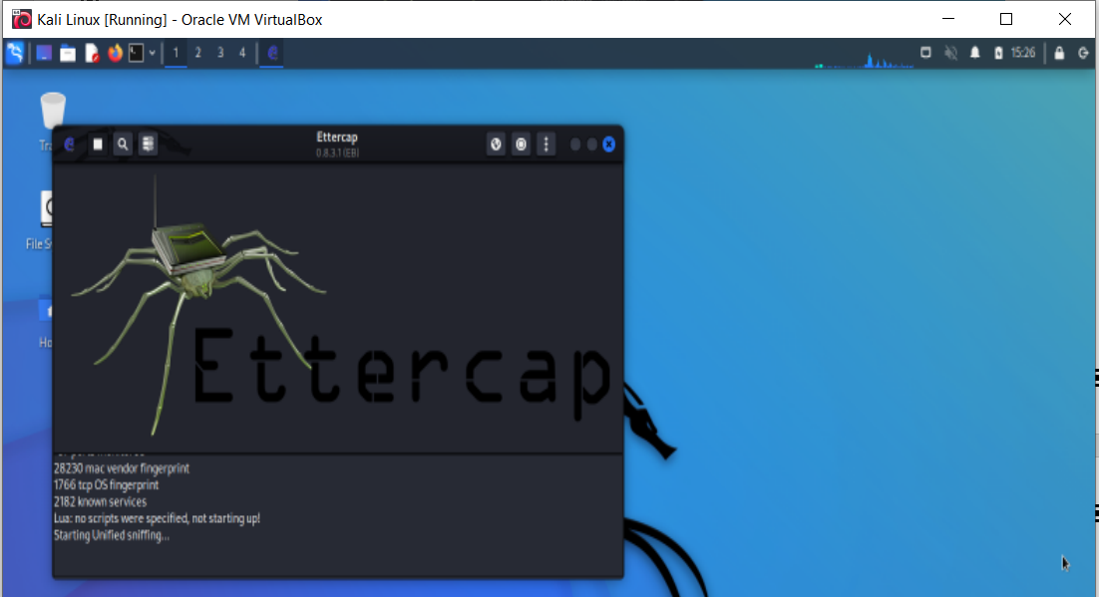

Figure 35 (Dashboard of Ettercap)

From the menu we found the following options here and we click on the scan for host.

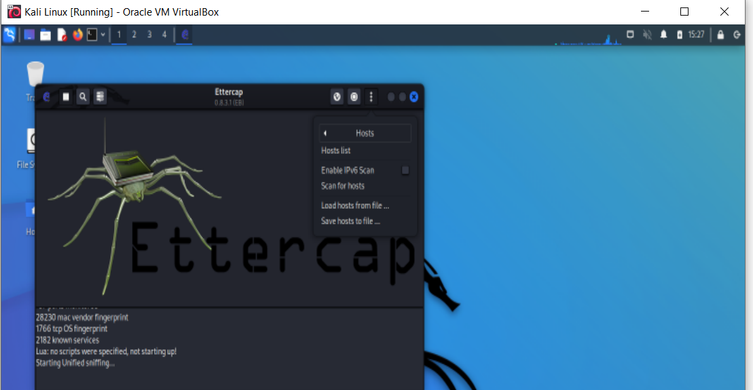

Figure 36 (Host List)

After that it shows me the following list of available hosts.

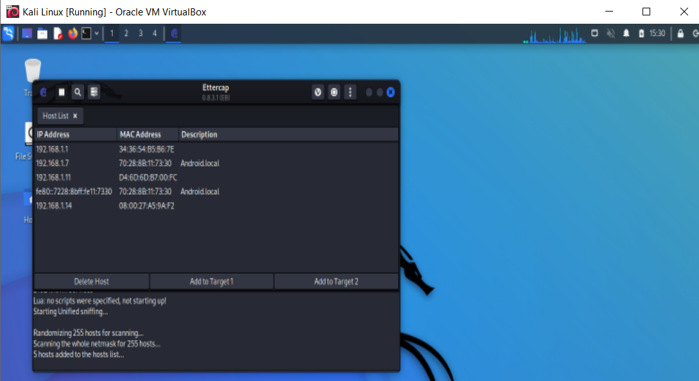

Figure 37(Host list)

After that we selected target host 192.168.1.14 as you can see below in screenshot.

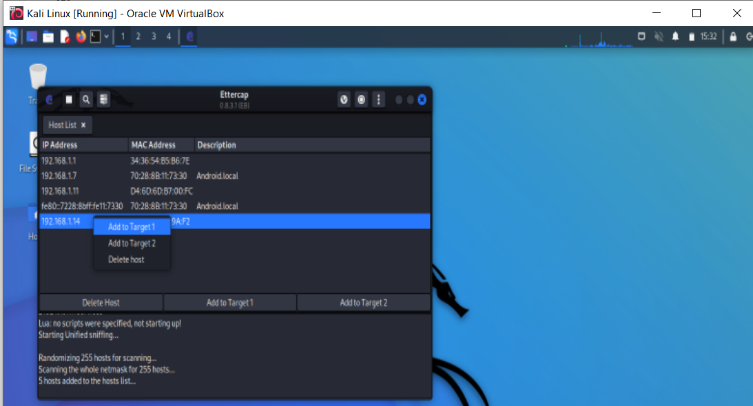

Figure 38(Added windows host to target 1)

Here you can see Host 192.168.1.14 has been added to Target1.

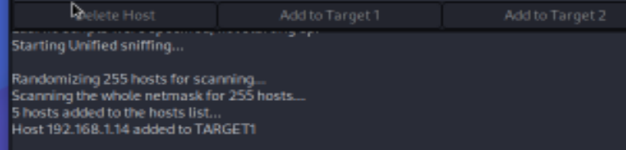

Figure 39(target 1)

After that we click on the manage plugins

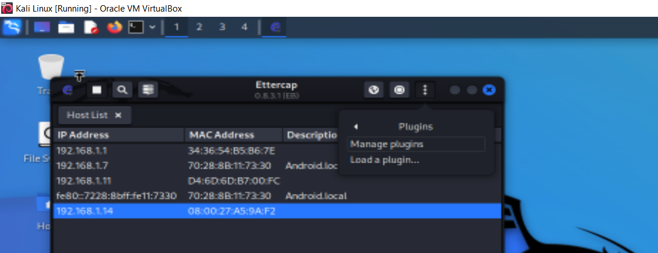

Figure 40 Manage plugins

Then I selected the DoS_Attack plugin to load it.

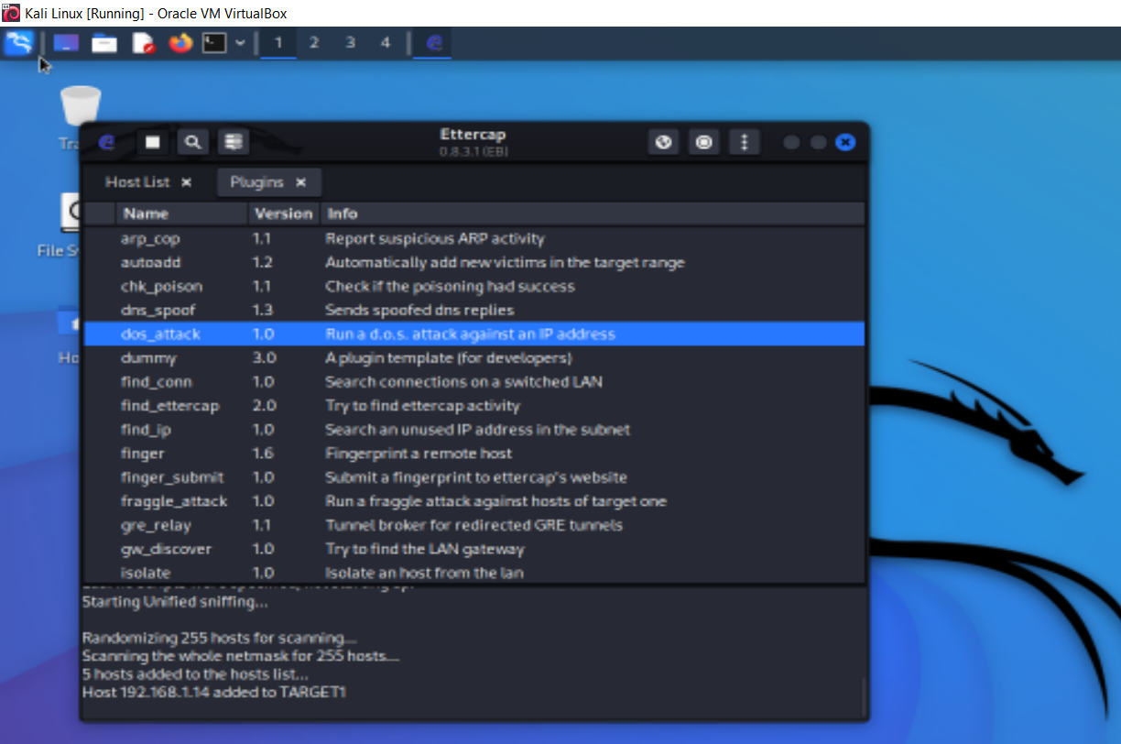

Figure 41(DoS_attack plugin)

After that when loaded the Dos_Attack then it required target user IP address

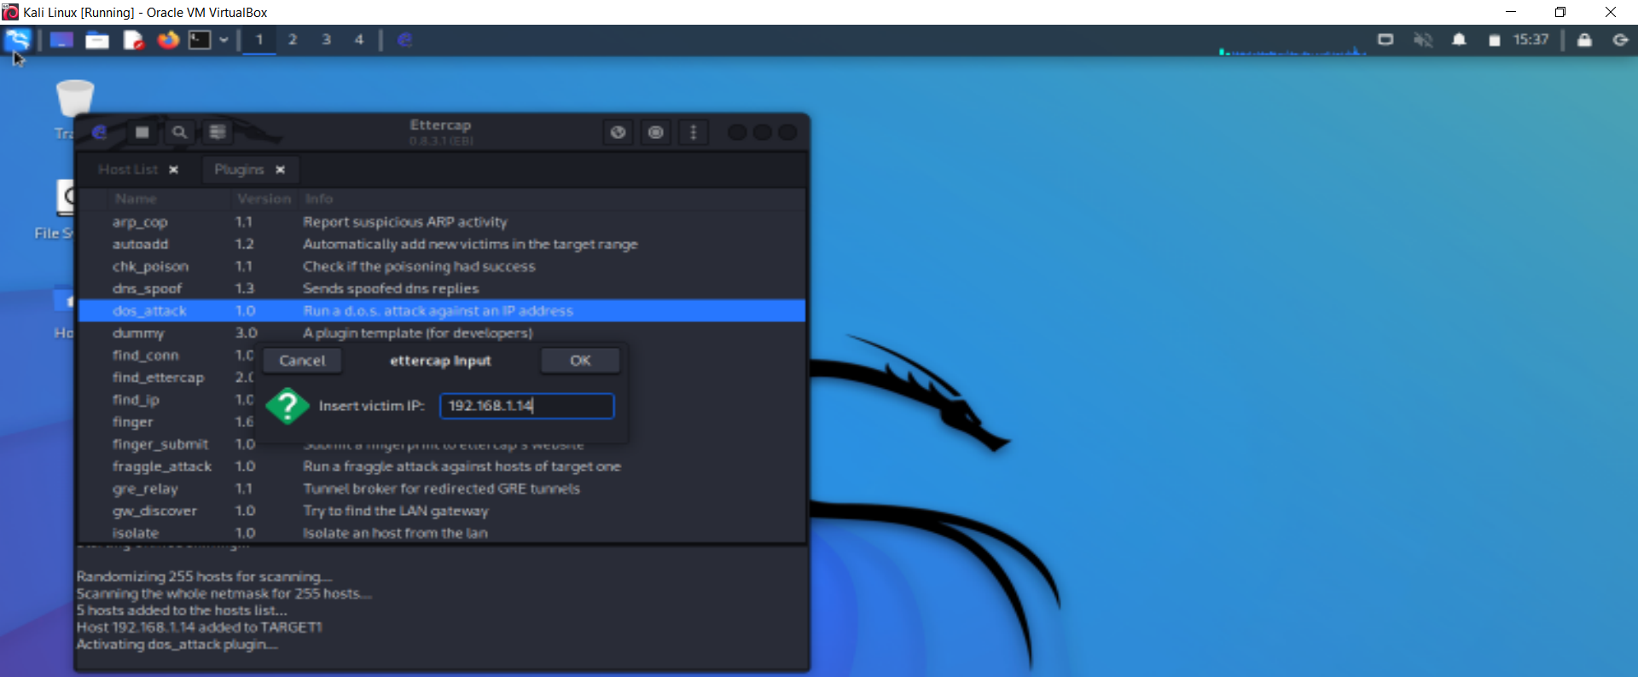

Figure 42(mentioned target IP)

Now after putting IP address of host DoS attack has been started as shown in screenshot below.

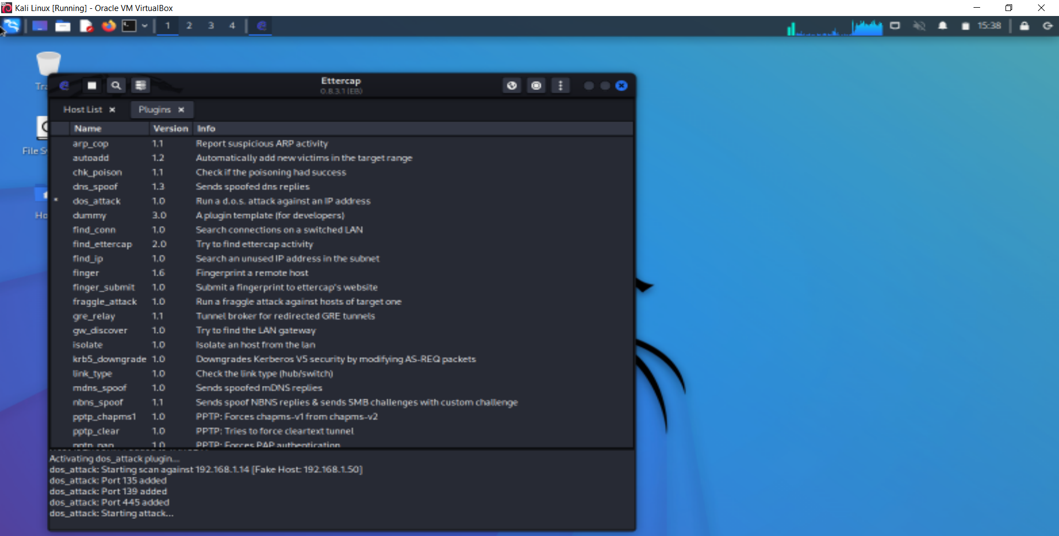

Figure 43(DoS attack Lauched)

Here you can see we am trying to open google and other websites and it’s not working because machine is under DoS attack.

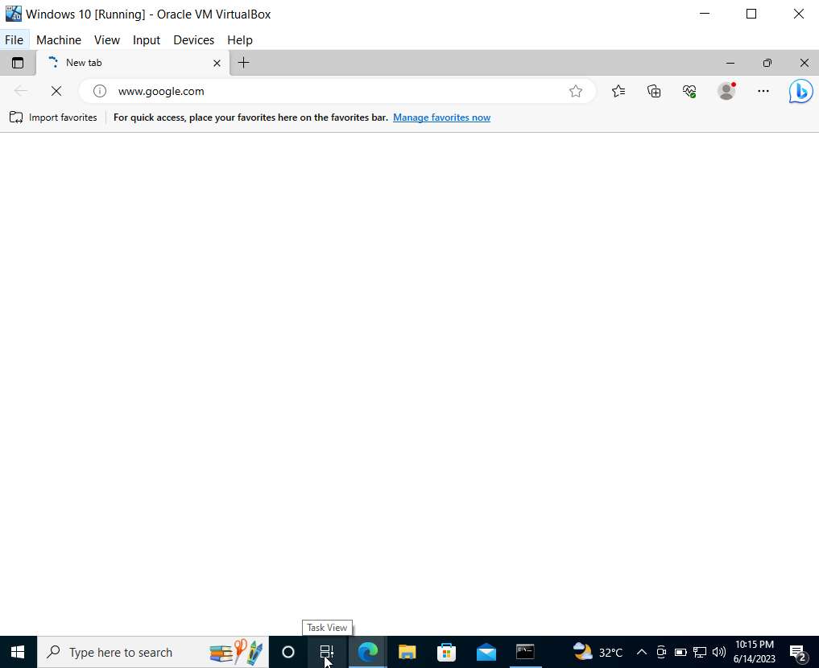

Figure 44(browsing on target vm)

Traffic details shown the attack you can see the red portion in Wireshark.

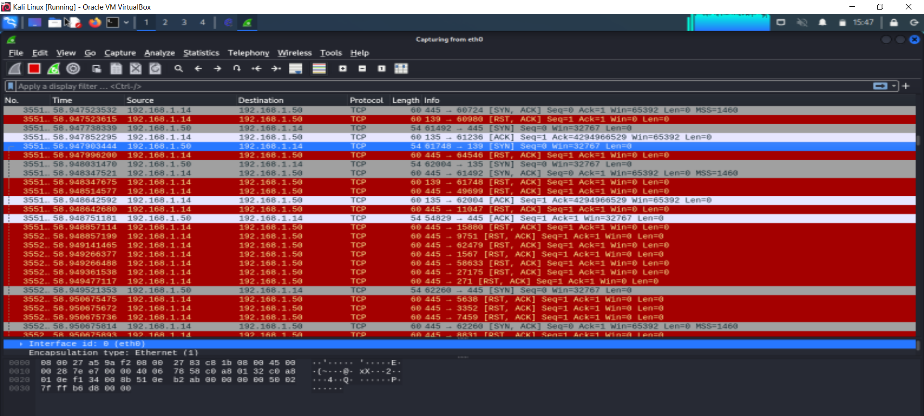

Figure 45 (Attack Traffic)

## 2.11 Evidence of Traffic

Here you can see in attached Wireshark Traffic analysis screenshot we captured the spoofed IP and windows host IP Traffic. The fake IP is the source of traffic it shown in screenshot attached.

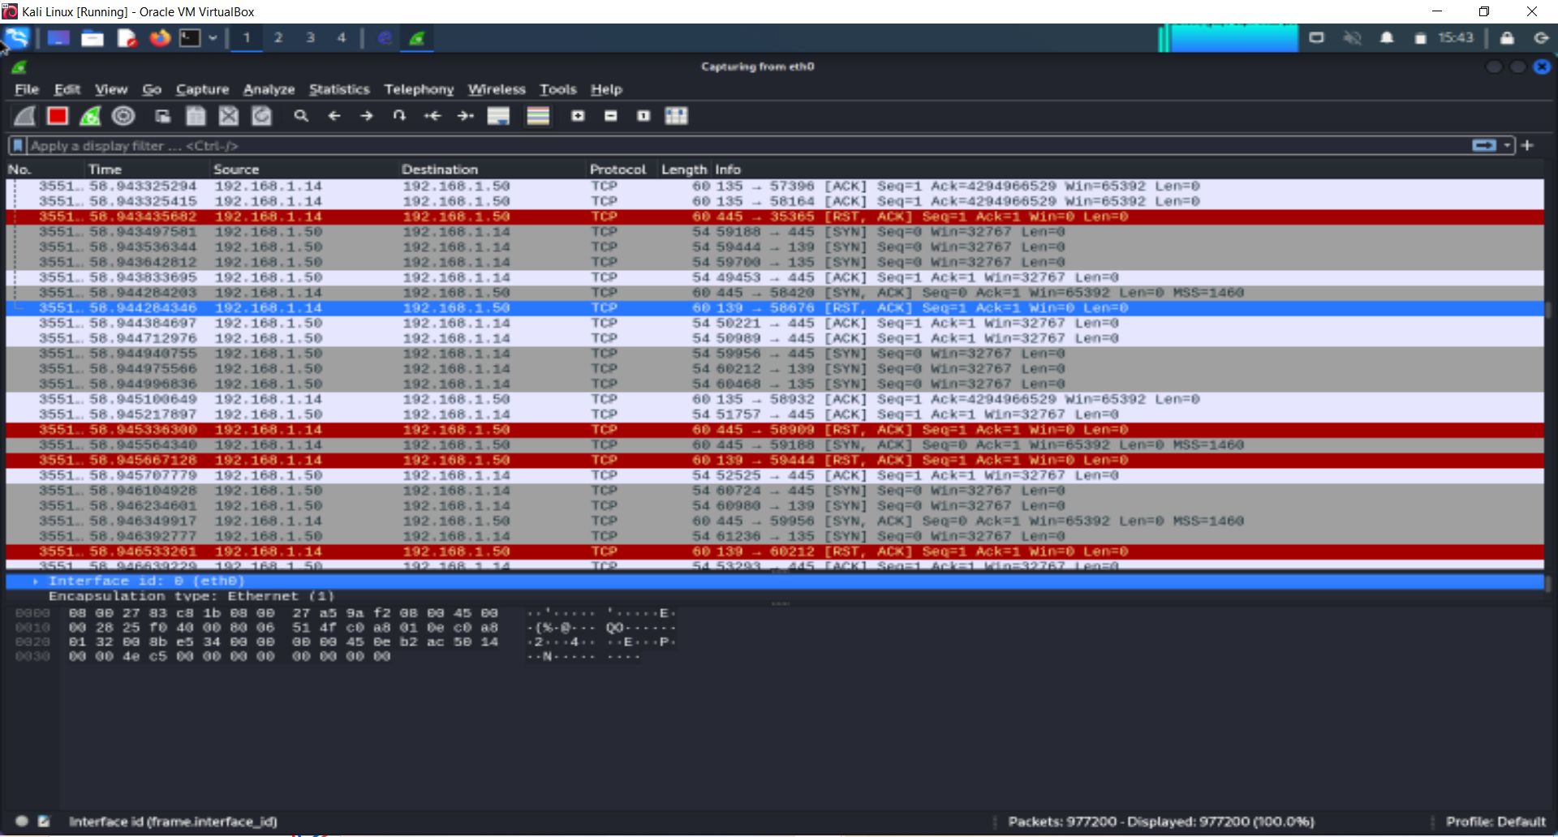

Figure 46(Wireshark ARP cache Traffic)

# **Objectives**

The primary objective of this project is to conduct a comprehensive assessment of the network's security through the implementation of various attacks, including ARP spoofing, Man-in-the-Middle (MitM) attack, and Denial-of-Service (DoS) attack. By executing these simulated attacks, we aim to evaluate the network's susceptibility to such threats and identify potential vulnerabilities.

Furthermore, the project aims to capture and analyze network traffic generated during these attacks. This forensic analysis will allow us to gather evidence and uncover any exploitable weaknesses or security gaps within the network infrastructure. The findings from the forensic analysis will be used to evaluate the effectiveness of the current security measures in place. By understanding the strengths and weaknesses of the network's defenses, we can provide actionable recommendations to enhance its overall security posture.

Ultimately, the objective is to ensure the network's resilience against attacks, protect sensitive information, and maintain the confidentiality, integrity, and availability of network resources. By addressing the identified weaknesses and implementing appropriate security enhancements, we strive to create a robust and secure network environment.

# **Forensic Analysis**

Forensic analysis of network ARP spoofing attack traffic involves investigating and analyzing the evidence related to an ARP spoofing attack within a network. ARP spoofing is a technique used by malicious actors to manipulate the Address Resolution Protocol (ARP) table, redirecting network traffic for their nefarious purposes. During forensic analysis, network traffic logs, packet captures, and network device configurations are examined to identify signs of ARP spoofing activity. The goal is to determine the source of the attack, the compromised devices involved, and the extent of the damage caused. Forensic analysts analyze the captured traffic patterns, IP-MAC mappings, and abnormal network behavior to reconstruct the attack timeline and identify potential victims. They also examine communication patterns, payload analysis, and system logs to gather evidence for potential legal actions. By conducting forensic analysis of network ARP spoofing attack traffic, organizations can identify the vulnerabilities that were exploited, implement appropriate security measures to prevent future attacks, and potentially gather evidence for legal proceedings against the perpetrators.

## 4.1 Man-In-Middle Attack Forensic Analysis

Man-In-Middle attack network traffic we captured while the attack you can see below in the traffic duplicate IP address detected for 192.168.10.26 as shown in screenshot.



Figure 47(Man-in-Middle Attack)

## 4.2 ARP Cache poisoning Attack Forensic Analysis

While performing the ARP cache posinoin attack we also monitor the traffic against the ARP cache poisnoning attack below you can see the traffic details in screenshot.



Figure 48(ARP cache poisoning Attack)



Figure 49 (Http stream)

## 4.3 DoS Attack Forensic Analysis

We performed the forensic analysis of DoS attack through Wireshark traffic we analyze the packets as you can see below the traffic.

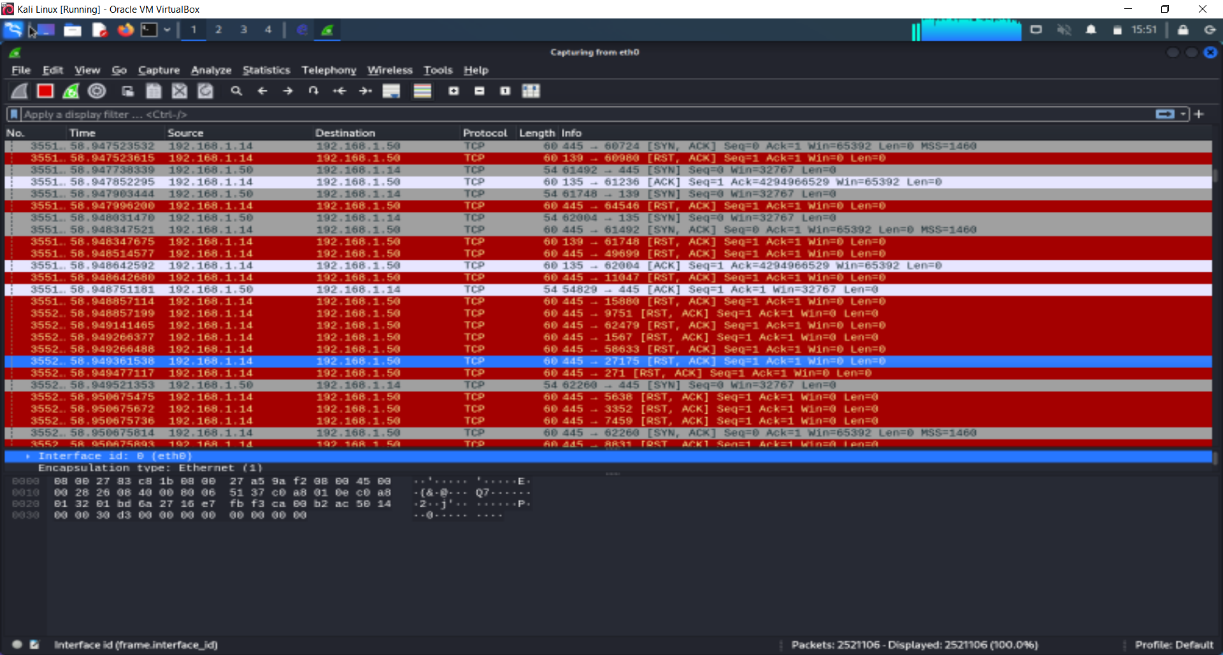

Figure 50 (Wireshark traffic)

We analyze the attack arrival time its Jun 14, 2023 15:41:15 and the frame no is 355203 as you can see below.

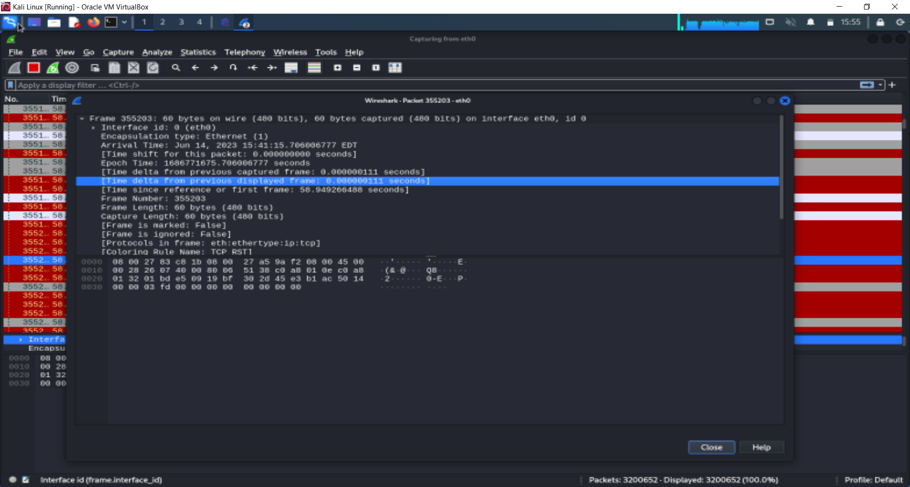

Figure 51 (Packet Detail)

# **Relevant Findings**

## 5.1 Findings Man-In-Middle Attack

The captured traffic data indicates a Man-in-the-Middle (MITM) attack. The attacker successfully positioned themselves between the sender and receiver, intercepting network traffic. Frame 283 shows an Address Resolution Protocol (ARP) reply with a duplicate IP address detected for both 192.168.10.26 and 192.168.10.6, indicating multiple devices using the same IP address. This highlights the presence of unauthorized devices in the network. The attack involves intercepting TLSv1.2 encrypted traffic between the source IP address 104.21.75.211 and destination IP address 192.168.10.24, with TCP retransmissions and duplicate acknowledgments observed. The attacker aims to capture sensitive information transmitted between these endpoints. It is crucial to investigate and mitigate this attack promptly to ensure the security and integrity of the network.

## 5.2 Findings of ARP Cache Poisoning Attack

The Wireshark traffic details show an ARP cache poisoning attack. The attacker's IP address, 8.255.130.126, is impersonating the IP address of the destination, 192.168.10.28. The attack involves sending HTTP requests from the attacker's IP to the destination, using the GET method to retrieve certain software updates. The attack is aimed at intercepting and manipulating the network traffic between the attacker and the destination. The captured packets reveal a series of HTTP 405 status code responses, indicating that the requested resources are not allowed. The attack is ongoing, with a total of 3,748 captured packets out of 105,283 packets observed.

## 5.3 Findings of DoS Attack

The traffic details indicate a Denial of Service (DoS) attack. The attack targets IP addresses 192.168.1.14 and 192.168.1.50. The attacker initiates TCP connections with the SYN flag set, attempting to establish multiple connections simultaneously. The attacked IPs respond with SYN-ACK packets. However, the attacker sends RST-ACK packets to terminate the connections, causing disruption. The attack involves repeated exchange of TCP packets between the attacker and the targets, specifically using port 445. The attack continues with a large number of packets captured (2521106) and displayed. The captured packets reveal a pattern of SYN-ACK and RST-ACK packets, indicating an attempt to overwhelm the targets and deny their services.

# **Challenges and troubleshooting**

First, we didn't face a lot of challenges throw the three attacks we have been working on it. Actually, the only problem or issue we faced was when we put the two virtual machines which are the Kali machine and the Windows machine on separate devices, and they didn't work well resulting in some errors. To overcome them and troubleshoot this issue, we combined the virtual machines on the same device, and they worked effectively.

# **Conclusions**

Based on the analysis of the network security assessment and forensic investigation, several significant findings have been identified. The evidence reveals the occurrence of a Man-in-the-Middle (MitM) attack, ARP spoofing attack, and Denial-of-Service (DoS) attack. These simulated attacks have exposed vulnerabilities in the network infrastructure, compromising its integrity and confidentiality. The presence of duplicate IP addresses and abnormal network behavior indicates successful manipulation of the Address Resolution Protocol (ARP) table. Furthermore, the DoS attack resulted in the network being overwhelmed with excessive traffic, rendering it inaccessible to legitimate users. These findings emphasize the critical importance of implementing robust security measures and continuously monitoring network activities to detect and prevent such attacks. It is essential for organizations to enhance their network defenses, such as implementing intrusion detection and prevention systems, traffic filtering, and regularly updating security protocols, to safeguard against these threats. Failure to do so may result in significant damage to network resources, potential data breaches, and financial losses.

# **References**

[1] Corey, V., Peterman, C., Shearin, S., Greenberg, M. S., & Van Bokkelen, J. (2002). Network forensics analysis. IEEE Internet Computing, 6(6), 60-66.

[2] Meghanathan, N., Allam, S. R., & Moore, L. A. (2010). Tools and techniques for network forensics. arXiv preprint arXiv:1004.0570.

[3] Ndatinya, V., Xiao, Z., Manepalli, V. R., Meng, K., & Xiao, Y. (2015). Network forensics analysis using Wireshark. International Journal of Security and Networks, 10(2), 91-106.

[4] Hunt, R., & Zeadally, S. (2012). Network forensics: an analysis of techniques, tools, and trends. Computer, 45(12), 36-43.

[5] Sikos, L. F. (2020). Packet analysis for network forensics: A comprehensive survey. Forensic Science International: Digital Investigation, 32, 200892.

[6] Saad, S., & Traore, I. (2010, August). Method ontology for intelligent network forensics analysis. In 2010 Eighth International Conference on Privacy, Security and Trust (pp. 7-14). IEEE.